ASSIGNMENT 4
1. How are inline and block elements different from each other?
2. Explain the difference between visibility:hidden and display:none
3. Explain the clear and float properties.
4. Explain difference between absolute, relative,fixed and static.
5. Write the HTML code to create a table in which there are 4 columns( ID , Employee Name, Designation, Department) and at least 6 rows. Also do some styling to it.
6. Why do we use meta tags?
7. Explain box model.
8. What are the different types of CSS Selectors?
9. Define Doctype.
10. Explain 5 HTML5 semantic tags.
11. Create HTML for web-page.jpg (check resources, highest weightage for answers)
12. Create HTML for form.png (check resources, highest weightage for answers)
Note: 50% of marks are for last 2 exercises of creating html pages

ANSWERS
Q1. How are inline and block elements different from each other?
Ans.
Basically, an inline element does not cause a line break (start on a new line) and does not take up the full width of a page, only the space bounded by its opening and closing tag. It is usually used within other HTML elements.
Other examples of inline elements are:
- anchor <a> tag
- emphasis <em> tag
- image <img> tag
where as
A block-level element always starts on a new line and takes up the full width of a page, from left to right. A block-level element can take up one line or multiple lines and has a line break before and after the element.
Other examples of the block-level tag are:
- Heading tags <h1> to <h6>
- List (Ordered, Unordered, Description and List Item) tags <ol>, <ul>, <dl>, <li>

Q2. Explain the difference between visibility:hidden and display:none
ans.
Hiding an element can be done by setting the display property to none. The element will be hidden, and the page will be displayed as if the element is not there
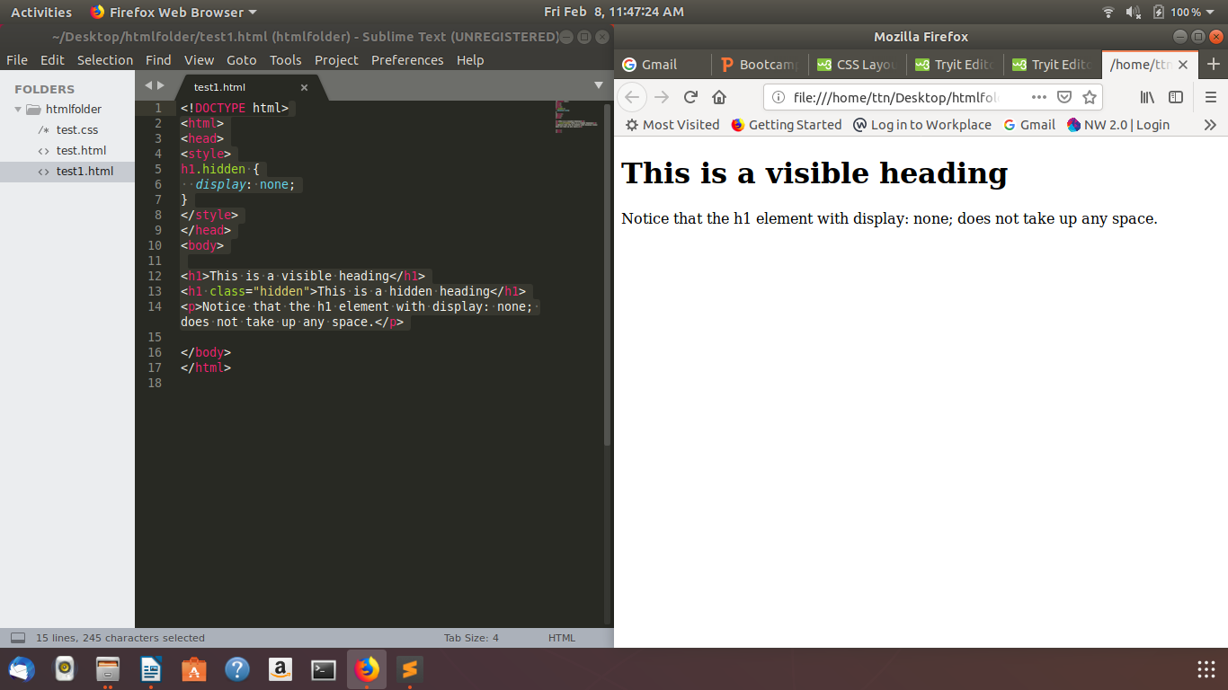
visibility:hidden also hides an element.
However, the element will still take up the same space as before. The element will be hidden, but still affect the layout

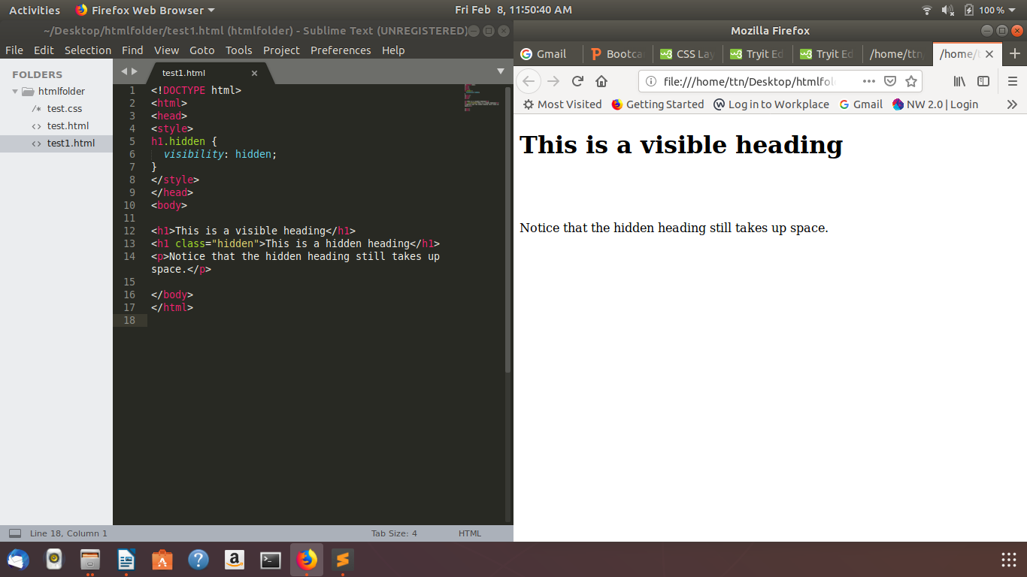
Q3. Explain the clear and float properties.
Ans.

The float property is used for positioning and formatting content e.g. let an image float left to the text in a container.
The float property can have one of the following values:
- left - The element floats to the left of its container
- right- The element floats to the right of its container
- none - The element does not float (will be displayed just where it occurs in the text). This is default
- inherit - The element inherits the float value of its parent

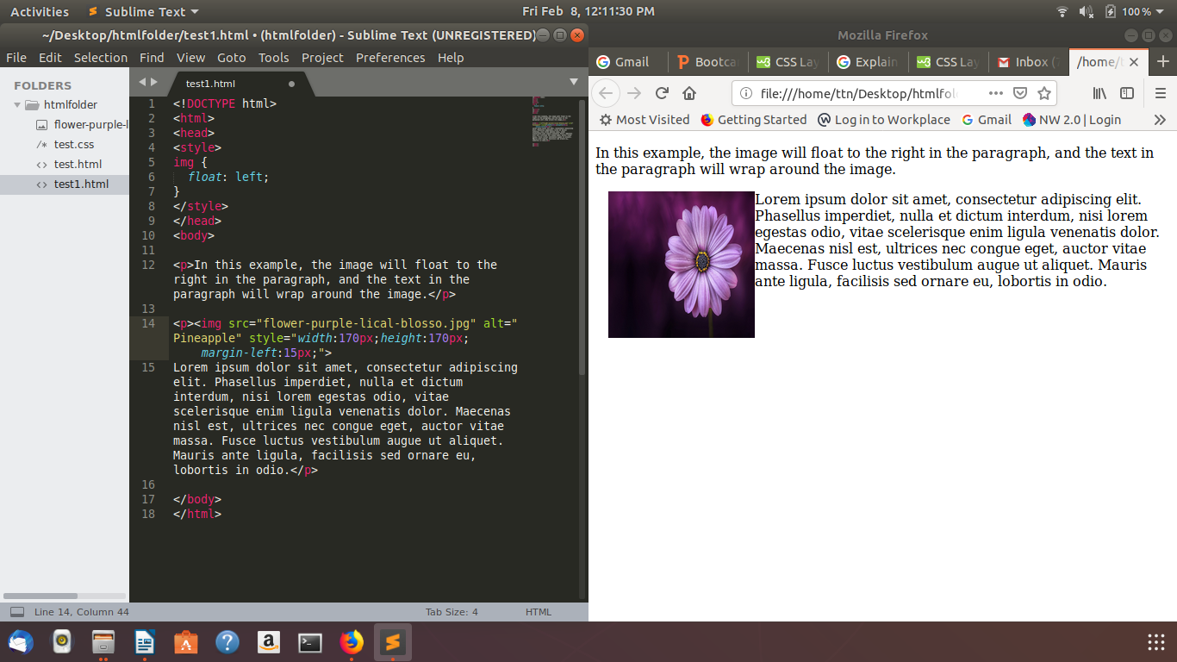

The clear property specifies what elements can float beside the cleared element and on which side.
The clear property can have one of the following values:
- none - Allows floating elements on both sides. This is default
- left - No floating elements allowed on the left side
- right- No floating elements allowed on the right side
- both - No floating elements allowed on either the left or the right side
- inherit - The element inherits the clear value of its parent
The most common way to use the clear property is after you have used a float property on an element.
When clearing floats, you should match the clear to the float: If an element is floated to the left, then you should clear to the left. Your floated element will continue to float, but the cleared element will appear below it on the web page.
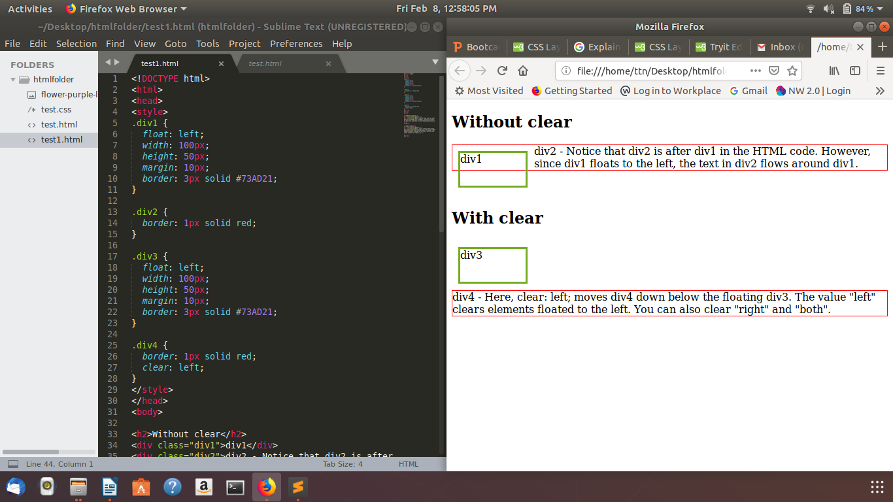
Q4. explain difference between absolute, relative,fixed and static.
Ans.

position: static
HTML elements are positioned static by default.
Static positioned elements are not affected by the top, bottom, left, and right properties.
An element with position: static; is not positioned in any special way; it is always positioned according to the normal flow of the page

position: relative
An element with position: relative; is positioned relative to its normal position.
Setting the top, right, bottom, and left properties of a relatively-positioned element will cause it to be adjusted away from its normal position. Other content will not be adjusted to fit into any gap left by the element.

position: fixed
An element with position: fixed; is positioned relative to the viewport, which means it always stays in the same place even if the page is scrolled. The top, right, bottom, and left properties are used to position the element.
A fixed element does not leave a gap in the page where it would normally have been located.

position: absolute
An element with position: absolute; is positioned relative to the nearest positioned ancestor
However; if an absolute positioned element has no positioned ancestors, it uses the document body, and moves along with page scrolling.

Q5. Write the HTML code to create a table in which there are 4 columns( ID , Employee Name, Designation, Department) and at least 6 rows. Also do some styling to it.
Ans.
<!DOCTYPE html>
<html>
<head>
<title>HTML Table Cellpadding</title>

<style>
table, th, td {
border: 1px solid black;
border-collapse: collapse;
}
th, td {
padding: 10px;
}
table#alter tr:nth-child(even) {
background-color:#FF6347;
}
table#alter tr:nth-child(odd) {
background-color:#00FA9A;
}
table#alter th {
color: white;
background-color: gray;
}
</style>

</head>

<body>
<table id= alter border = "1" cellpadding = "5" cellspacing = "10">
<tr>
<th>id</th>
<th>employee name</th>
<th>designation</th>
<th>department</th>
</tr>

<tr>
<td>5000</td>
<td>Ramesh Raman</td>
<td>po</td>
<td>computer science</td>
</tr>

<tr>
<td>5001</td>
<td>Ramesh Raman</td>
<td>manager</td>
<td>computer science</td>
</tr>

<tr>
<td>5002</td>
<td>suresh</td>
<td>po</td>
<td>computer science</td>
</tr>

<tr>
<td>5003</td>
<td>parth</td>
<td>manager</td>
<td>computer science</td>
</tr>

<tr>
<td>5004</td>
<td>tushar</td>
<td>manager</td>
<td>computer science</td>
</tr>

<tr>
<td>5005</td>
<td>rohit</td>
<td>qa</td>
<td>computer science</td>
</tr>

<tr>
<td>5006</td>
<td>virat</td>
<td>ba</td>
<td>computer science</td>
</tr>

</table>
</body>
</html>

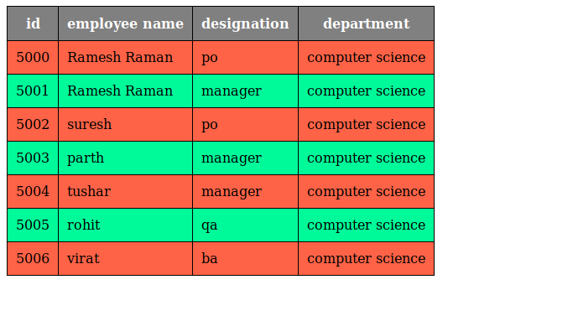

Q6. Why do we use meta tags?
Ans.Metadata is data (information) about data.
The <meta> tag provides metadata about the HTML document. Metadata will not be displayed on the page, but will be machine parsable.
Meta elements are typically used to specify page description, keywords, author of the document, last modified, and other metadata.
The metadata can be used by browsers (how to display content or reload page), search engines (keywords), or other web services.
Q7. Explain box model.
Ans.
All HTML elements can be considered as boxes. In CSS, the term "box model" is used when talking about design and layout.
The CSS box model is essentially a box that wraps around every HTML element. It consists of: margins, borders, padding, and the actual content.
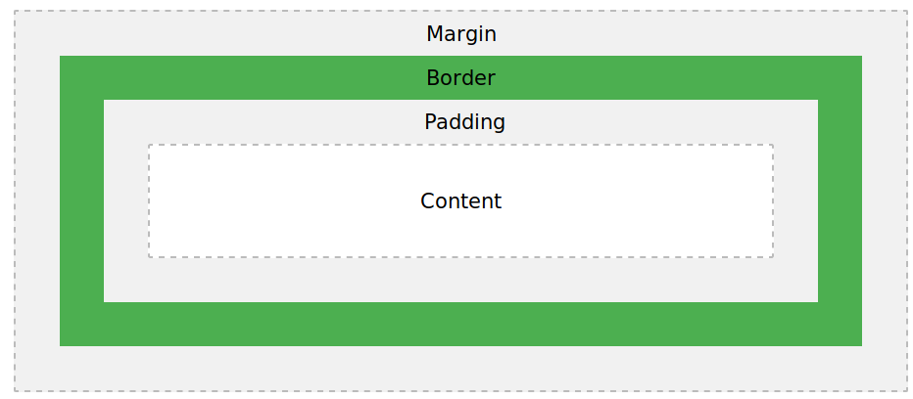

Content - The content of the box, where text and images appear
Padding - Clears an area around the content. The padding is transparent
Border - A border that goes around the padding and content
Margin - Clears an area outside the border. The margin is transparent

Q8. What are the different types of CSS Selectors?
Ans. There are several different types of selectors in CSS.
- CSS Element Selector
- CSS Id Selector
- CSS Class Selector
- CSS Universal Selector
- CSS Group Selector

1.The element selector selects the HTML element by name.
example :
p{
text-align: center;
color: blue;
}

2.The id selector selects the id attribute of an HTML element to select a specific element. An id is always unique within the page so it is chosen to select a single, unique element.
It is written with the hash character (#), followed by the id of the element.
Eg :
#para1 {
text-align: center;
color: blue;
}
3.1The class selector selects HTML elements with a specific class attribute. It is used with a period character . (full stop symbol) followed by the class name.
Eg :
.center {
text-align: center;
color: blue;
}

3.2If you want to specify that only one specific HTML element should be affected then you should use the element name with class selector.
eg:
p.center {
text-align: center;
color: blue;
}

4.The universal selector is used as a wildcard character. It selects all the elements on the pages.
Eg :
* {
color: green;
font-size: 20px;
}

5.The grouping selector is used to select all the elements with the same style definitions.
Grouping selector is used to minimize the code. Commas are used to separate each selector in grouping.
Eg:
h1, h2, p {
text-align: center;
color: blue;
}

9. Define Doctype.
Ans.
The <!DOCTYPE> declaration is not an HTML tag; it is an instruction to the web browser about what version of HTML the page is written in.

10. Explain 5 HTML5 semantic tags.
Ans. 1.The <section> element defines a section in a document.
2.The <article> element specifies independent, self-contained content.
3.The <header> element specifies a header for a document or section.
The <header> element should be used as a container for introductory content.
4.The <footer> element specifies a footer for a document or section.
5.The <nav> element defines a set of navigation links.

11. Create HTML for web-page.jpg
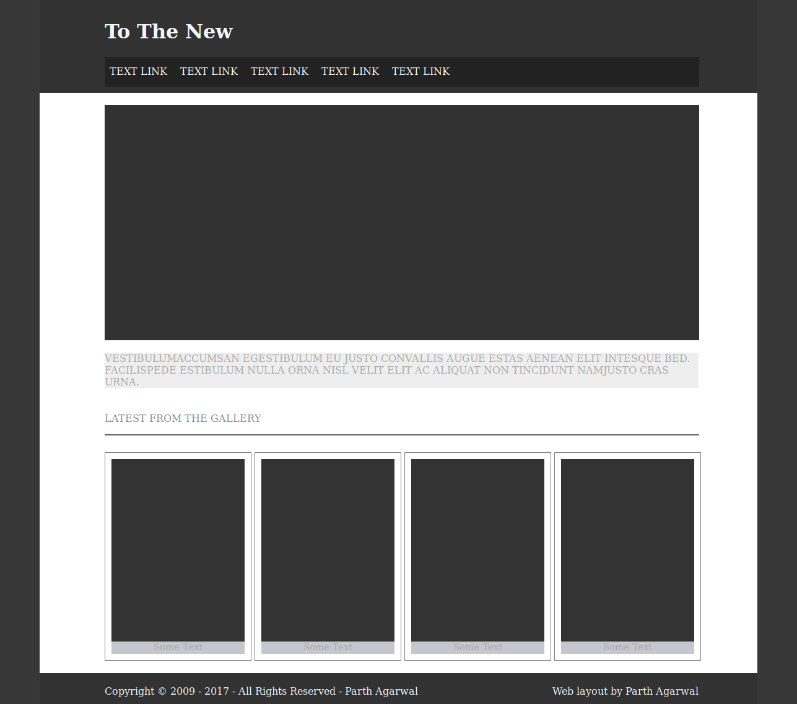
11. Create HTML for form.jpg
